**Instance of Object example program**

1. . Write a program to declare the variables for the particular object and access the variables.

class const:

def display(self):

print("a=",self.a,"b=",self.b,"c=",self.c)

pass

ob=const()

ob.a=15

ob.b=20

ob.c="Arun"

ob.display()

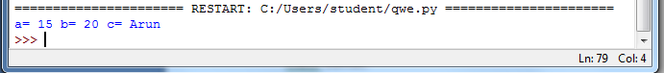

2. Write a program to declare the variables inside the method and access the variables

class const:

def inta(self):

print("Inside Constructer")

self.a=10

self.b=5

self.c=15

def display(self):

print("a=",self.a,"b=",self.b,"c=",self.c)

pass

ob=const()

ob.inta()

ob.display()

print("B=",ob.b)

